CHAPTER -1

INTRODUCTION

A Can Crusher is a pneumatic device which is used for squashing food and beverage cans to save space for recycling. The disposal of the used cans can pose a problem because the empty cans occupy space. Also the transport of empty cans become difficult. There is a need to crush these cans. So that they occupy smaller space for storage & transport. This will help recycling of the material of the can. It can be placed everywhere, in the park, houses. To design the pneumatic part of a can crusher and to fabricate the pneumatic part of the system is the step to learn pneumatic engineering.

Recycling plays a very important role to save our natural resources, as all we know we have limited natural resources. Now days, all packaging materials available are made up of recycling material only like paper, Aluminum, etc. and also we have a different recycling processes for material like plastic polymers.

We have different processes available for different material like computer parts, cartridges of printer, plastic carry bag, plastic bottles, and of course Aluminum tin for cold drinks. Cold drinks and Soft drinks are available in small Aluminum can, as Aluminum is light weight material, easily recycle at very low cost then other material, and also available at low price than other material.

Anyone who has ever tried to recycle aluminum cans has experienced the massive amount of space they can take up. You can easily fill up several garbage bags with a small number of cans, and before you know it, you can have whole rooms filled with bags that weigh almost nothing. The big problem is that empty cans are mostly air, so when you try to store them, they take up a lot more space than they have to. This problem is exacerbated if you live in an area where you have to personally transport your cans to be cycling facility.

This inefficiency and wasted space has led to the invention of a handy device called a can crusher, and if you’re going to get serious about recycling, they’re a must have item. There are many different designs for can crushers but they all have one thing in common; they save you a lot of space, and they make it a lot easier to store old cans for recycling.

A lot of people recycle cans for financial reasons, and it can really pay off when you have a can crusher, because it means fewer trips to bring more cans. A bag full of crushed cans in the current market will add up to around Rs.400/- and that is a drastic improvement over the total you get with uncrushed cans. Because of the convenience they add to the recycling process and the money they save you, these devices tend to pay for themselves very quickly.

There are various methods, by which these cans are crushed by different types of can crushers. Some can crushers, crush the can by pressing into it from both the sides, while some can crushers smash the can from above. The two prominently used methods of can crushing are pneumatic method, wherein the cans are crushed by machines powered by electricity, and manual method, wherein the cans are crushed by machines operated manually by humans.

1.1 NEED FOR CAN CRUSHER

It is well known that in a modern society, refuse is being generated in larger amounts than in earlier times when man lived more self-sufficiently. Today many of the foods we eat, come in tinned cans which after being emptied, must be discarded, so that in a relatively short time, an average household accumulates a larger volume of such refuse, which is usually put into bags for being carted away by refuse collectors. These empty cans, as presently being placed in a bag, take up a lot of space, so that the bag is soon filled up. Accordingly, there seems to be a need for some means whereby more cans can be fitted in a bag for purpose of greater efficiency in handling.

Therefore it is a principal object of the present invention, to provide a machine that crushes emptied cans so that they take up less space, thus allowing more of them to fit inside a bag.

1.2 PROBLEM STATEMENT

Users of this Can are facing problem of storage, after using it. When people footstep the tin after finishes their drink, the tin always not look symmetrically flat and it look messy. This condition sometime makes tin produce the sharp adage will harm or injured the people.

Furthermore, people always throw the can anywhere. These conditions makes pollution for this environment, become bad surrounding and separate the ditches.

So it is necessary to design equipment or device, which is used to crush these cans as flat as possible and try to reduce time, cost consuming with large volume while in the transporting.

1.3 ABOUT THE PROJECT

In this project, we developed the pneumatic Can Crusher which is operated by air pressure. The air flow is controlled by a valve which is operated manually.

This project is mainly about generating new concepts of pneumatic can crusher that would make easy and easier to crush the tin. And this project involves the process of designing the crusher manually and then it was transferred to solid modeling using design Software, because it gives a better dimension of pneumatic can crusher compared to manual draw and is much easier to use. And finally the design was transformed to real product by means of fabrication. The processes involved in fabrication are welding, drilling, cutting, turning and bending.

CHAPTER -2

LITERATURE SURVEY & DATA COLLECTION

Can recycling is a very important part of any family and community recycling program. Aluminum recycling is one of the easiest things you can do to help the environment. Recycling of can began long ago and started to become common place back in the early 1970s.

Can is 100% renewable. This means that the can you take to your local recycling center today becomes a new aluminum can. There are no waste products in the process of making aluminum a 100% renewable resource and one of the best things you can recycle. You might be surprised to know that within 60 days an aluminum can is able to go from your recycling center and become a brand new can to be used by consumers.

2.1 CRUSHER

A crusher is a machine designed to reduce large solid material objects into a smaller volume, or smaller pieces. Crushers may be used to reduce the size, or change the form, of waste materials so they can be more easily disposed of or recycled, or to reduce the size of a solid mix of raw materials (as in rock ore), so that pieces of different composition can be differentiated.

Crushing is the process of transferring a force amplified by pneumatic advantage through a material made of molecules that bond together more strongly, and resist deformation more, than those in the material being crushed do.

Crushing devices hold material between two parallel or tangent solid surfaces, and apply sufficient force to bring the surfaces together to generate enough energy within the material being crushed. so that its molecules separate from (fracturing), or change alignment in relation to (deformation), each other.

The earliest crushers were hand-held stones, where the weight of the stone provided a boost to muscle power, used against a stone anvil. Querns and mortars are types of these crushing devices.

2.2 INDUSTRIAL USE

In industry, crushers are machines which use a metal surface to break or compress materials. Mining operations use crushers, commonly classified by the degree to which they fragment the starting material, with primary and secondary crushers handling coarse materials, and tertiary and quaternary crushers reducing ore particles to finer gradations. Each crusher is designed to work with a certain maximum size of raw material, and often delivers its output to a screening machine which sorts and directs the product for further processing. Typically, crushing stages are followed by milling stages if the materials need to be further reduced. Crushers are used to reduce particle size enough so that the material can be processed into finer particles in a grinder. A typical circuit at a mine might consist of a crusher followed by a SAG mill followed by a ball mill. In this context, the SAG mill and ball mill are considered grinders rather than crushers.

In operation, the raw material (of various sizes) is usually delivered to the primary crusher's hopper by dump trucks, excavators or wheeled front-end loaders. A feeder device such as a conveyor or vibrating grid controls the rate at which this material enters the crusher, and often contains a preliminary screening device which allows smaller material to bypass the crusher itself, thus improving efficiency. Primary crushing reduces the large pieces to a size which can be handled by the downstream machinery.

2.3 PNEUMATICS
Pneumatics is a section of technology that deals with the study and application of pressurized gas to produce mechanical motion. Pneumatic systems, which are used extensively in industry, and factories, are commonly plumbed with compressed air or compressed inert gases. This is because a centrally located and electrically powered compressor, that powers cylinders and other pneumatic devices through solenoid valves, can often provide motive power in a cheaper, safer, more flexible, and more reliable way than a large number of electric motors and actuators.

2.4 SELECTION OF PNEUMATICS
Mechanization is broadly defined as the replacement of manual effort by mechanical
power. Pneumatics is an attractive medium for low Cost mechanization particularly for
sequential (or) repetitive operations. Many factories and plants already have a compressed air
system, which is capable of providing the power (or) energy requirements and control system
(although equally pneumatic control systems may be economic and can be advantageously
applied to other forms of power).
2.5 PRODUCTION OF COMPRESSED AIR
An air compressor is a machine that uses an electric motor or gas engine to power a
device that sucks in successive volumes of air from the atmosphere, compresses (squeezes)
each volume of air in a confined place to increase its pressure by making the volume smaller,
and then transfers the high-pressure air to a receiver tank, The high-pressure air is drawn off
from the receiver tank to power equipment.

2.6 ADVANTAGES OF PNEUMATICS

1) Infinite availability of the source
Air is the most important thing in the pneumatic system, and as we all know, air is available in the world around us in unlimited quantities at all times and places.

2) Easy channelled
Air is a substance that is easily passed or move from one place to another through a small pipe.

3) Safe
The air can be loaded more safely than it is not flammable and does not short circuit occurs or explode, so protection against both of these things pretty easily.

4) Clean
The air around us are tend to clean without chemicals that are harmful, and also, it can be minimized or cleaned with some processes, so it is safe to use pneumatic systems to the pharmaceutical industry, food and beverages and textiles.

5) Pneumatic systems are simple and economical
6) Control of pneumatic systems is easier
7) Compressed gas can be stored, so machines still run for a while if electrical power is lost.

2.7 DISADVANTAGES OF PNEUMATICS
1) Requires installation of air-producing equipment.
Compressed air should be well prepared to meet the requirements. Meet certain criteria, such as dry, clean, and contain the necessary lubricant for pneumatic equipment. Therefore require Installations of pneumatic systems are relatively expensive equipment, such as compressors, air filter, lube tube, dryer, regulators, etc.

2) Easy to leak

One of the properties of pressurized air is like to always occupy the empty space and the air pressure is maintained in hard work. Therefore we need a seal so that air does not leak. Seal leakage can cause energy loss. Pneumatic equipment should be equipped with airtight equipment that compressed air leaks in the system can be minimized.

3) Potential noise

Pneumatic using open system, meaning that the air that has been used will be thrown out of the system, the air comes out pretty loud and noisy so will cause noise, especially on the exhaust tract. The fix is ​​to put a silencer on each dump line.

4) Easy condenses

Pressurized air is easily condensed, so before entering the system must be processed first in order to meet certain requirements, such as dry, have enough pressure, and contains a small amount of lubricant to reduce friction in the valves and actuators.

5) Higher pressure cannot be achieved in pneumatic system

CHAPTER - 3

METHODOLOGY

3.1 FORCE TESTING ON UTM

Initially we determined the force which is required to crush the can on the

Universal Testing Machine as 0.8 KN at 15mm.

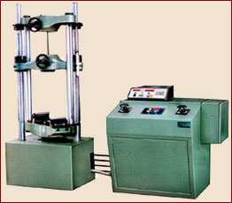

Fig.3.1: Universal Testing Machine

3.2 DESIGN OF PNEUMATIC CAN CRUSHER

Varieties of designs are available for Can Crusher in market depending of final users need from multi Can Crusher to Single Can Crusher. Actually we design a pneumatic can crusher for crushing a soft drink cans of length 150mm appx.

In our design, we designed a Can Crusher, which is made for single Can. This is made up of very few parts. This design is very simple and one can make this device. This device is operated by air compressor. After the selection of design, we develop the drawings.The drawings are diving into two categories, which are:

Sketching: The idea for tin can crusher fabrication is sketched on the paper.

PRO-E Application: The design or concept sketched is transfer to part modeling using PRO-E.

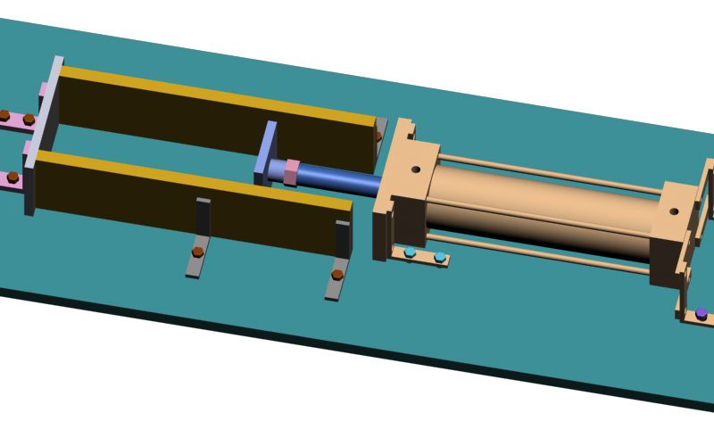
Fig3.2: Assembly view of pneumatic can crusher

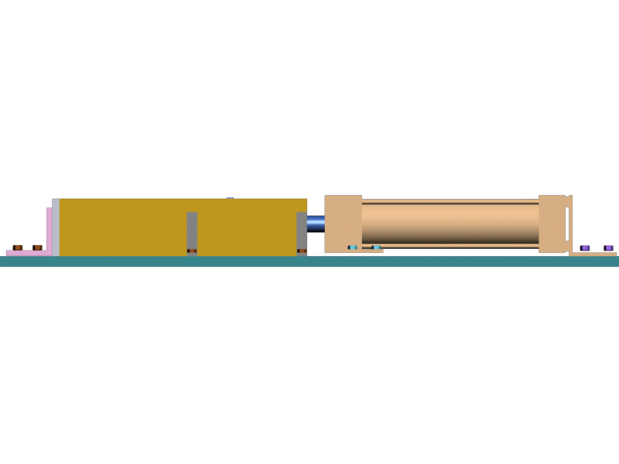

Fig3.3: Front view of pneumatic can crusher

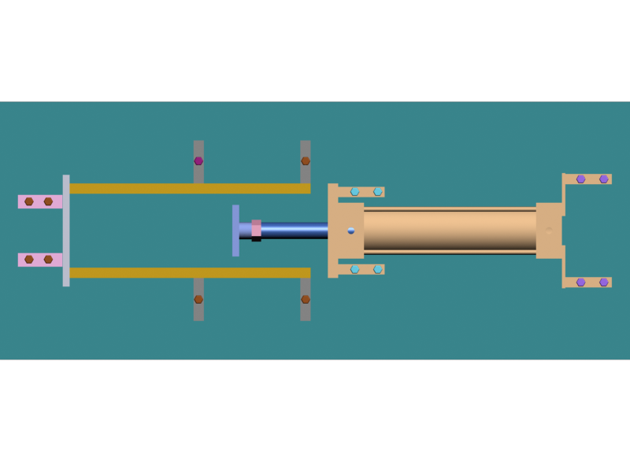
Fig.3.4: Top view of pneumatic can crusher

3.3 DESIGN SPECIFICATIONS

The following table illustrates the design specifications.

PARTS | MATERIAL | TYPE | SIZE(mm) | QUANTITY
piston | Mild steel | Metal plate | 200*20 | 2
Supporting  plates | Mild steel | wood | 280*65*15 | 2
Frame | Mild steel | angular | 25*25*4 | 1
fixed plate | Mild steel | Sheet metal | 110*65*10 | 1
Pneumatic Cylinder | Aluminium & stainless steel | cylinder | 50*200 | 1

Table 3.1: Design Specifications

3.4 COMPONENTS OF PNEUMATIC CAN CRUSHER

- Base plate

- Supporting plates

- Pneumatic cylinder

- Flow control valve

- Air flow lines

- Silencer

- Quick coupler

- Polyurethane tubes

- Air compressor

3.4.1 SUPPORTING PLATES

We provide the guide way between two plates called supporting plates. On this
Setup the slider will move. These are made with wood.

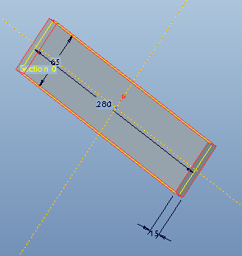

Fig.3.5: Supporting Plates

3.4.2. DOUBLE-ACTING CYLINDERS
Double-acting cylinders (DAC) use the force of air to move in both extend and
retract strokes. They have two ports to allow air in, one for outstroke and one for instroke.
Stroke length for this should be performed as well design is not limited, however, the piston
rod is more vulnerable to buckling and bending.

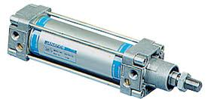

Fig.3.6: Pneumatic cylinder

CYLINDER SPECIFICATIONS:

Bore dia :50mm

Stroke length :100mm

3.4.3. DIRECTION CONTROL VALVE

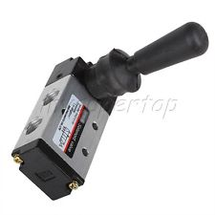

Fig.3.7: Pneumatic flow control valve

Direction flow-control valves are vital in any pneumatic circuit, directing or blocking airflowto control the speed or sequence of operations. One method of classifying direction -control valves is by the flow paths under various operating conditions. Important factors are the number of possible valve positions and the number of ports and flow paths. Here are somebasic configurations.

In this project we have used four way two position control valve .

Four-way, two-position valves have four or five ports with two or three positions. A two-position valve has two distinct flow paths in each position to actuate and reverse cylindersrotary actuators, or bidirectional motors. The spool directs flow from the pressure port while the other actuator port exhausts to atmosphere at the same time.

3.4.4. AIR FLOW LINES

Function
• These valves allow controlled flow of air in one direction and free flow in the other
direction.
Application
• These valves are used to control the speed of piston in a pneumatic cylinder.

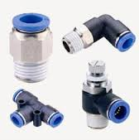

Fig .3.8: air flow lines

3.4.5. SILENCER

Silencers are used to reduce the noise of the exhaust air.

FEAUTRERS
- Brass body and sintered bronze silencer elements
- Button, Conical, Silencer cum flow control (with lock nut), Silencer cum flow control (with spring) types
- Good flow and silencing characteristics
- Can be cleaned by kerosene and soap water

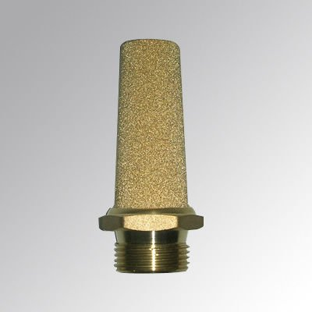

Fig.3.9: Silencer

3.4.6. QUICK COUPLER

This can be effectively used in all compressed air line applications - Some of them Include
• All compressed air lines.
• Assembly lines with pneumatic tools / Machinery with pneumatic systems
• Pneumatic control panels.
3.4.7. PVC PIPE

It is used to connect the pneumatic cylinder and direction control valve. Pipe diameter is 4mm . it is a pvc pipe.

3.4.8. AIR COMPRESSOR

An air compressor is a device that converts power (usually from an electric motor, a dieselengine or a gasoline engine) into kinetic energy by compressing and pressurizing air, which,on command, can be released in quick bursts.

A reciprocating compressor or piston compressor is a positive-displacement compressor

that uses pistons driven by a crankshaft to deliver gases at high pressure.

The intake gas enters the suction manifold, then flows into the compression cylinder where it gets compressed by a piston driven in a reciprocating motion via a crankshaft, and is then discharged.

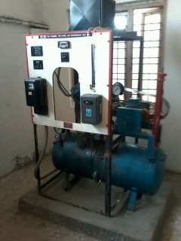

Fig.3.10: air compressor

3.5 FORCE CALCULATIONS

Force (F) = pressure (P) * area (A)

F = Compressed air force required to crush the can

F = 800 N

It is measured by using universal testing machine.

Pressure (P) = Pressure available from air compressor

= 6 bars

Area (A) = Area of the air cylinder

= (π × ԁ^2) / 4

F = P × A

800 = 6×10^5 (π×d^2) / 4

ԁ = 41.21 mm

ԁ ≈ 50 mm

ԁ = Diameter of the cylinder

3.6 FABRICATION PROCESS

After designing phase, fabrication processes take place. These processes are about using material selection and make the product base on the design and by followed the design dimension. Many methods can be used to fabricate a product, like welding, cutting, bending, grinding, drilling and many more methods. Fabrication process is a process to make only one product rather the manufacturing process was used at the whole system production. This way include part by fabrication until assembly to other components.

In order to make the design come reality, fabrication process needs to be done first. The fabrication process starts from dimensioning the raw material until we finish as a desire product. The processes that involve are:

3.6.1 MEASURING AND MARKING

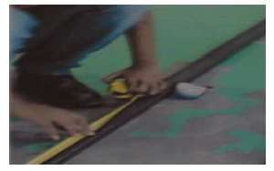

Fig.3.11: Measurement and marking the material

After getting the material, the next step is measurement and marking material like Fig3.13. The equipment used in this process is measuring tape or steel rule and scriber all the components are marked as per required dimensions.

3.6.2 CUTTING MATERIAL

After the measurement and marking process, figure 4.3 introduce the process cutting the material using cutting machine.

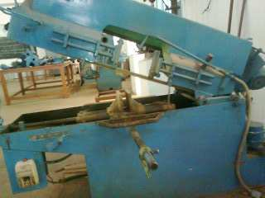

Fig.3.12: Cutting Machine

On the cutting machine , we cut the materials for making the desired shape and sizes of L- angular, fixed plate

3.6.3 GRINDING

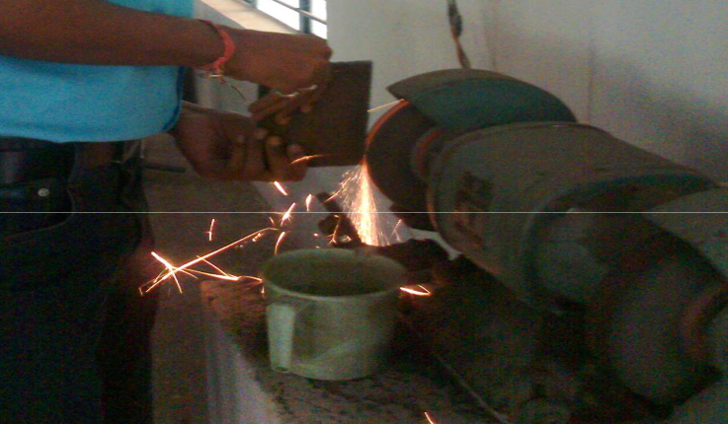

Fig.3.13: Bench Grinder
3.6.4 DRILLING

Drilling is the most common machining process whereby the operation involves making round holes in metallic and nonmetallic materials.
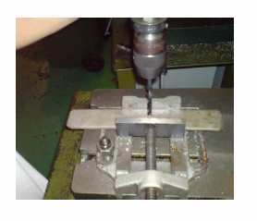

Fig.3.14: Drilling process

After cutting the material, it is need to make holes for the parts like wooden sheet, clamps, frame, by different drill bits. So, mark the position to drill using steel rule and scriber and then punch a small hole by using centre punch before start drill. After that, start the drilling like Figure 3.14.

3.6.5 WELDING

Arc welding is a type of welding that uses a welding power supply to create an electric arc between an electrode and the base material to melt the metals at the welding point. By using this we make the frame and the handle
.

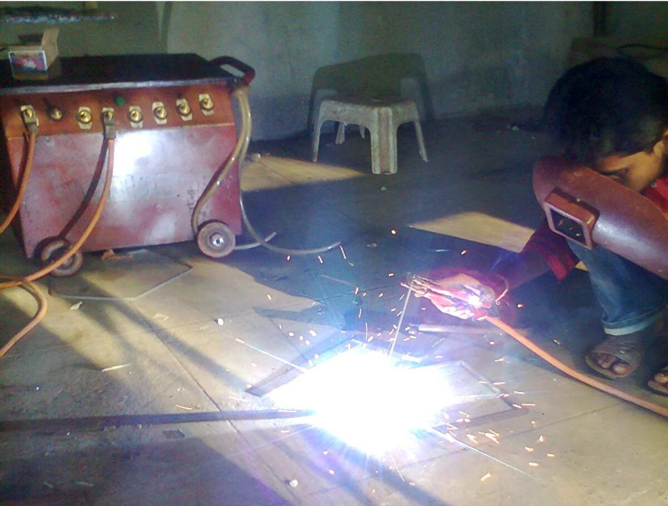

Fig.3.15: welding process

CHAPTER-4
OPERATION OF PNEUMATIC CAN CRUSHER

This chapter involved working operation and the performance of the pneumatic can crusher, and compared the results before and after the crushing of cans.

4.1 WORKING OF PNEUMATIC CAN CRUSHER

crusher is
After completing the fabricating process, the final product i.e., pneumatic can

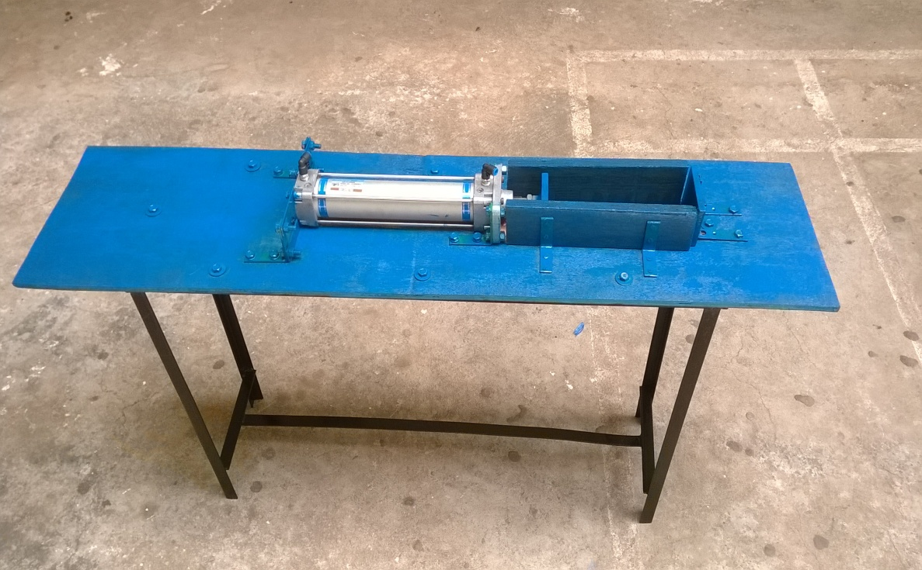

Fig 4.1: Pneumatic Can Crusher

This figure shows the final product i.e., Pneumatic Can Crusher, which works on the principle of compressed air.

First place the beverage can on the wooden frame between fixed plate and ram force is applied to the piston by supplying the compressed air in to pneumatic cylinder. Then the piston moves forward direction, The beverage can between fixed plate and ram crushes due to the forward stroke of the piston. Finally the beverage can is crushed.

4.1.1 RESULT AFTER FINISHING

After finishing the final product, we crushed the cans and we got a flat shaped
Beverage Can which its length is reduced from 150mm to 30mm. Hence, by using this pneumatic can crusher we are able to crush the number of cans very easily.

Fig4.2: Before crush the tin

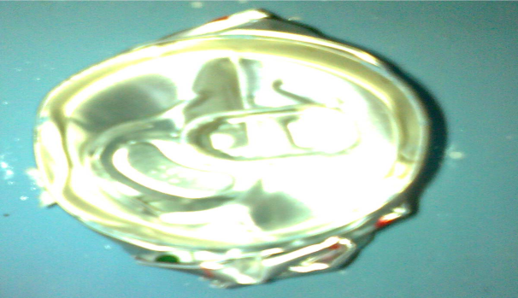

Fig4.3: After crush the tin

And all these crushed cans are packaged and transport to the factory for recycling.

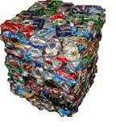
Fig4.4: packaging of cans

4.2 ADVANTAGES & LIMITATIONS OF PNEUMATIC CAN

CRUSHER

4.2.1 ADVANTAGES OF PNEUMATIC CAN CRUSHER

Less expensive

Eco friendly

By reducing size huge amount of cans can be transported for recycling

Easy to handle

Occupy less space

Easy to fabricate

4.2.2 LIMITATIONS OF PNEUMATIC CAN CRUSHER

It is not able crush high strength material cans

It can’t crush the can completely

4.3 APPLICATIONS

It is used in industries, restaurants, domestic use in the kitchens, etc.

CHAPTER-5

CONCLUSIONS

In this project, we designed the pneumatic can crusher manually and generated

in 3d model by using pro-E design software.

The pneumatic can crusher was fabricated.

From all the results obtained, the design was practically done safe to operate.

5.1 SCOPE FOR FUTURE EXTENSION

By placing the electric motor instead of manually operated gives more results

The pneumatic can crusher can be make with electrical & hydraulic

Systemalso.
REFERENCES

1. Theory Of Machines by R.S. Kurmi , J.K. Gupta

2. Machine Design by R.S. Kurmi , J.K. Gupta

3. www.google.com

4. http://en.wikipedia.org/wiki/Can Crusher

5. www.answers.com

6. www. Howstuffworks.com

7. Design data book by PSG TECH

