SOLAR WATER PUMP

SOLAR WATER PUMP

MAIN PROJECT REPORT

Submitted in partial fulfillment of the requirement for the award of degree

of

Bachelor of Technology

in

Mechanical Engineering

Submitted by

AMIT JAISWAL (5808614)

Under the esteemed guidance of

DR. .........................,B.Tech, M.Tech.,Ph.D

Head of Department

Of

Mechanical Engineering
.................................. ENGINEERING COLLEGE
(Affiliated to ...................................... University)

2014-2015

TABLE OF CONTENTS
S.NO. | TOPIC | PAGE NO.
1 | CANDIDATE’S DECLARTION | 4
2 | CERTIFICATE | 5
3 | ACKNOWLEDGEMENT | 6
4 | ROLE AND RESPONSIBILITIES | 7
5 | PERSONAL ENGINEERING ACTIVITY | 8
6 | ABSTRACT | 9
7 | INTRODUCTION | 10
8 | SOLAR PUMPING SYSTEM | 15
9 | USE OF SOLAR ENERGY | 16
10 | PHOTOVOLTAIC POWER GENERATION | 20
11 | SYSTEM COMPONENTS | 29
12 | MAINTENANCE OF SPV SYSTEM | 29
13 | ADVANTAGES | 30
14 | CONCLUSION | 32
15 | REFERENCES | 32
CANDIDATE’S DECLARTION

I hereby certify that the work which is being presented by Amit Jaiswal, Ajay Singh Chauhan, Rajeev Kumar, Raman Kumar, Vijay Kumar in partial fulfillment of requirement for the award of degree of B.Tech. in MECHANICAL ENGINEERING submitted at KALPI INSTITUTE OF TECHNOLOGY under KURUKSHETRA UNIVERSITY, KURUKSHETRA is an authentic record of my own work carried out under the supervision of Er. Harish Kumar Sharma (HOD) and Er. Vikas Kunnar.

Project Member:
Amit Jaiswal [5808614] Ajay Singh Chauhan [5808615] Rajeev Kumar [5808608] Raman Kumar [5808606] Vijay Kumar [5808613]

CERTIFICATE

This is certify that the dissertation entitled “ SOLAR WATER PUMP ” by RAJEEV KUSHWAHA, AMIT JAISWAL, SANDEEP ANAND SHARMA, MANISH KUMAR TRIVEDI, PERVEZ KHAN,& DIVYANSH submitted to the Department of mechanical engineering, Kalpi Institute Of Technology, Ambala in the partial fulfillment of requirement for the award of Degree of Bachelor of Technology in mechanical engineering is a record of bonafide work done by him under my supervision and guidance during the session 2014-15. This work has not been submitted to any other university or institute for the award of any degree or diploma.

Head of department & project Guide
Mr.........................
Department of mechanical engineering

ACKNOWLEDGEMENT

First of all we would like to thank our project guide Mr. ...................... Assistant Professor, Mechanical engineering Department, Kurukshetra University who has given valuable support during the course of our project by clarifying our doubts and guiding us with her novel ideas.

We would like to thank Prof. .........................., Head of department, mechanical engineering, Kurukshetra University.

We extend our sincere thanks to our Dean .................................... Department of mechanical engineering for giving us this wonderful opportunity to work in desired area of interest.

We extend our sincere thanks to all teaching staff of mechanical engineering department, those who helped us in completing this project successfully.

Lastly we also thank the people who directly or indirectly gave us encouragement and support throughout the project.

Role and Responsibilities
My roles and responsibilities includes:
- Prepare a requirement document to reach expectations of project and to come up with functionalities which are needed to be implemented.
- Documentation of expected output for various aspects with accepted margin error was also documented.
- To design overall system based on workflow requirements.
- Discussion with the project guide and Head of Department on ways to improve the design and to optimize performance.
- Choosing suitable components and methods based on the configurations availability and requirements.
- Testing and remedies.
- Recommendations

As a trainee mechanical engineer, I wanted to work on a project work that would showcase my engineering knowledge. I got the opportunity to work on SOLAR WATER PUMP. This project was very important as it evaluated my skills and talents in my company.

PERSONAL ENGINEERING ACTIVITY

As a mechanical engineer, before undertaking any task I checked the feasibility of the project. In this project, my role is as team members. This report provides an insight into the design and fabrication of a SOLAR WATER PUMP.
I wanted to know more details of the project before commencing; hence, I researched the topic thoroughly by referring to journals and articles online. Additionally, I obtained more information by taking references about the topic.

ABSTRACT

The performance of a solar water pumping system is discussed in this paper ;the system consists of a photovoltaic (PV) array, a permanent magnet (PM) DC motor and a helical rotor pump. The operation of the PV array is analysed using PSPICE. The efficiency of the system is improved with a maximum power point tracker (MPPT) and a sun-tracker. Simulation and field test results are presented.
INTRODUCTION
A solar-powered pump is a pump running on electricity generated by photovoltaic panels or the radiated thermal energy available from collected sunlight as opposed to grid electricity or diesel run water pumps.[1] The operation of solar powered pumps is more economical mainly due to the lower operation and maintenance costs and has less environmental impact than pumps powered by an internal combustion engine (ICE). Solar pumps are useful where grid electricity is unavailable and alternative sources (in particular wind) do not provide sufficient energy.

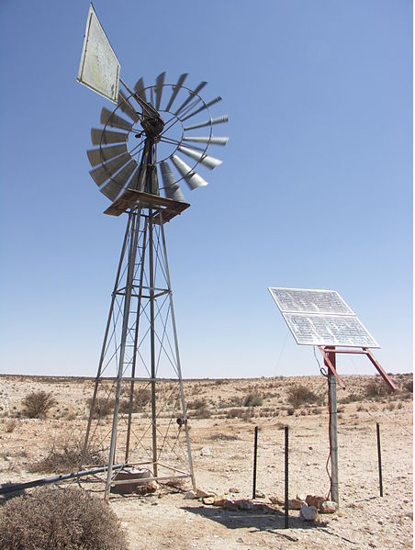
A windpump replaced by a solar powered pump at a water hole in the Augrabies Falls National Park.
MAIN COMPONENTS

A photovoltaic solar powered pump system has three parts:
- the pump
- the controller
- solar panels.
The solar panels make up most (up to 80%) of the systems cost.[citation needed] The size of the PV-system is directly dependent on the size of the pump, the amount of water that is required (m³/d) and the solar irradiance available.
The purpose of the controller is twofold. Firstly, it matches the output power that the pump receives with the input power available from the solar panels. Secondly, a controller usually provides a low voltage protection, whereby the system is switched off, if the voltage is too low or too high for the operating voltage range of the pump. This increases the lifetime of the pump thus reducing the need for maintenance.
Voltage of the solar pump motors can be AC (alternating current) or DC (direct current). Direct current motors are used for small to medium applications up to about 3 kW rating, and are suitable for applications such as garden fountains, landscaping, drinking water for livestock, or small irrigation projects. Since DC systems tend to have overall higher efficiency levels than AC pumps of a similar size, the costs are reduced as smaller solar panels can be used.

Finally, if an alternating current solar pump is used, an inverter is necessary that changes the direct current from the solar panels into alternating current for the pump. The supported power range of inverters extends from 0.15 to 55 kW and can be used for larger irrigation systems. However, the panel and inverters must be sized accordingly to accommodate the inrush characteristic of an AC motor.
Water pumping

Solar powered water pumps can deliver drinking water as well as water for livestock or irrigation purposes.[1] Solar water pumps may be especially useful in small scale or community based irrigation, as large scale irrigation requires large volumes of water that in turn require a large solar PV array.[2] As the water may only be required during some parts of the year, a large PV array would provide excess energy that is not necessarily required, thus making the system inefficient.
Solar PV water pumping systems are used for irrigation and drinking water in India. The majority of the pumps are fitted with a 200 watt - 3,000 watt motor that receives energy from a 1,800 Wp PV array. The larger systems can deliver about 140,000 liters of water/day from a total head of 10 meters. By 30 September 2006, a total of 7,068 solar PV water pumping systems have been installed.[3]

Oil and gas

In order to combat negative publicity related to the environmental impacts of fossil fuels, including fracking, the industry is embracing solar powered pumping systems.[4] Many oil and gas wells require the accurate injection (metering) of various chemicals under pressure to sustain their operation and to improve extraction rates. Historically, these chemical injection pumps (CIP) have been driven by gas reciprocating motors utilizing the pressure of the well's gas and exhausting the raw gas into the atmosphere. Solar powered electrical pumps (solar CIP) can reduce these greenhouse gas emissions. Solar arrays (photovoltaic cells) not only provide a sustainable power source for the CIPs but can also provide an electric source to run remote SCADA type diagnostics with remote control and satellite/cell communications from very remote locations to a desktop or notebook monitoring computer.
Stirling engine
Instead of generating electricity to turn a motor, sunlight can be concentrated on the heat exchanger of a Stirling engine and used to drive a pump mechanically. This dispenses with the cost of solar panels and electric equipment. In some cases the Stirling engine may be suitable for local fabrication, eliminating the difficulty of importing equipment. One form of Stirling engine is the fluidyne engine which operates directly on the pumped fluid as a piston. Fluidyne solar pumps have been studied since 1987 [5] At least one manufacturer has conducted tests with a Stirling solar powered pump.
Notes
Note that the pump-shaft has been removed from the windpump and it is no longer connected to the borehole; instead, the borehole now contains an electric pump powered by the solar panels.
SOLAR PUMPING SYSTEM FOR SMALL IRRIGATON PROJECTS
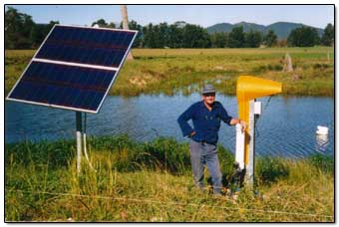
Energy is a key ingredient for the overall development of an economy. India has been endowed with abundant renewable solar energy resource. India is large country and the rate of electrification has not kept pace with the expanding population, urbanization and industrialization and has resulted in the increasing deficit between demand and supply of electricity. This has not only resulted in under electrification but also put heavy pressure on the governments to keep pace with demand for electricity. People not served by the power grid have to rely on fossil fuels like kerosene and diesel for their energy needs and also incur heavy recurring expenditure for the poor people in rural areas. Wherever the rural areas have been brought under power grid the erractic and unreliable supply has not helped the farmers and the need for an uninterrupted power supply especially during the critical farming period has been has been a major area of concern. India receives a solar energy equivalent of 5,000 trillion kWh/year with a daily average solar energy incidence of 4-7 kWh/m2. This is incidence of 4-7 kWh/m2. This is considerably more than the total energy consumption of the country. Further, most parts of the country experience 250-300 sunny days in a year, which makes solar energy a viable option in these areas.
Decentralized renewable energy systems, which rely on locally available resources, could provide the solution to the rural energy problem, particularly in remote areas where grid extension is not a viable proposition
Solar energy, with its virtually infinite potential and free availability, represents a nonpolluting and inexhaustible energy source which can be developed to meet the energy needs of mankind in a major way. The high cost, fast depleting fossil fuels and the public concern about the eco-friendly power generation of power have led to a surge of interest in the utilization of solar energy. To evaluate the energy potential at particular place, detailed information on its availability is essential. These include data on solar intensity, spectrum, incident angle and cloudiness as a function of time.
USE OF SOLAR ENERGY:
Solar energy can be utilized in two ways:
Solar Thermal (ST) technologies where the heat produced are used to operate devices for heating, cooling, drying, water purification and power generation. The devices suitable for use by village communities include solar hot water heaters, solar cookers and solar driers.
Solar Photovoltaic (SPV) systems which convert sunlight into electricity for use applications such as lighting, pumping, communication and refrigeration.
The Solar Energy Programme is prominent among the technology-based renewable energy programmes of the MNES. Areas covered under this programme include solar thermal technology (hot water systems, cookers, dryers, solar passive architecture etc.), solar photovoltaic technology (lanterns, fixed systems, pumpsets) as well as information dissemination, marketing, standardisation of products and R&D. The support to the programme is mainly in the form of subsidies and technical support.
Currently the MNES is promoting solar PV (and other) devices through (a) State nodal agencies of the MNES, (b) NGOs/CBOs, (c) authorized outlets of the MNES and (d) through local entrepreneurs.
SOLAR ENERGY FOR AGRICULTURE
The demand for electrical energy is far outstripping supply, especially in the agricultural sector, and it is becoming increasingly difficult to meet this exponential growth in demand Agricultural productivity is closely associated to direct and indirect energy inputs and policies are required to consolidate this relationship to the benefit of farmers. If rural development is to be achieved, energy inputs must be made available, and this might require special efforts from the country as a whole, to develop and utilize renewable energy sources most important being the solar energy, to their potential which remains far from being tapped to the potential. Rural electrification has eluded the most far flung rural areas of the countries. It is cost-prohibitive for the Government to extend utility grid power to remote areas especially to meet agriculture loads. An integrated approach for irrigation with water conservation with scientific agricultural practices the solar water pumping systems assume relevance for optimum exploitation of the water resource and serving the small/marginal farmers for all time to come.
Intersectoral cooperation is necessary, and should include government, financial institutions/banks, CBOs/NGOs and the private sector. It would appear that there is a strong case for the design of institutional mechanisms for encouraging closer cooperation and collaboration between institutions, in particular between the agricultural and energy sectors.

SOLAR ENERGY BASED WATER LIFTING AND PUMPING SYSTEMS FOR SMALL IRRIGATION PROJECTS
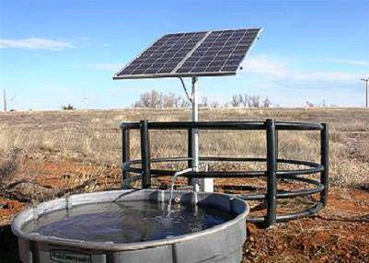
Among the solar technologies useful in agriculture are water lifting and pumping with solar photovoltaic systems. Water pumping by solar power is a concept which has won widespread interest since the early seventies. Solar energy can be utilized to operate pumps, utilizing either the thermal or light part of solar radiation. With a solar pump, energy is not available on demand, and the daily variation in solar power generation necessitates the storage of a surplus of water pumped on sunny days for use on cloudy days. In view of the fluctuating water demand of any irrigation scheme, solar energy needs to be reserved in the form of either electricity in batteries or lifted water in a storage tank. The suitability of solar power for lifting water to irrigate plants is undeniable because of the complementarity between solar irradiance and water requirements of crops. The more intensively the sun is shining the higher is the power to supply irrigation water while on the other hand on rainy days irrigation is neither possible nor needed.
Small scale irrigation is one of the most potential applications of solar power. The main advantage is that solar radiation is intense when the need for irrigation is high. Further, solar power is available at the point of use, making the farmer independent of fuel supplies or electrical transmission lines. The solar pumps have the potential to revolutionize small scale irrigation in the developing countries in the near future. The technical feasibility of solar (photo voltaic) pumps have been established.The major limiting factor has been the high cost and the lack of familiarity of the technology which require concerted effort in training of technicians and large scale introduction in a region with adequate technical support.However with the incentives and initiatives undertaken by MNES/State Govt the scheme may be propagated in rural areas for small irrigation system in far flung rural areas where electrification is a costly proposition.
The model scheme is to introduce solar water pumping and support irrigation schemes to provide a sustainable economic activity to farmers in unelectrified or under electrified rural areas .Various agencies and financial institutions are in place to assist in developing credit scheme targeted for unelectrified rural area.

PHOTOVOLTAIC POWER GENERATION
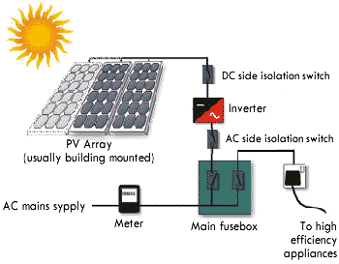

Photovoltaic cells frequently referred to as solar cells, convert the light part of the solar spectrum (Sunlight) into electricity. They are the most rapidly expanding energy sources in the world. Large scale manufacture of photovoltaic cells, coupled with continued research and development is expected to further make photovoltaic with in the economic framework of rural areas in developing countries.

SOLAR CELLS
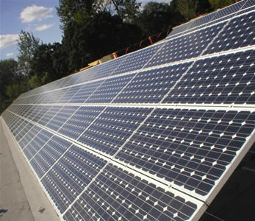
Specifications
250watt solar panel made of Taiwan high efficiency and quality solar cells (156*156mm 60pieces)
Made by Taiwan high quality poly crystalline cells
Peak power Output WP (W): 250Wp
Best voltage Vmp (V):29.4V
Best electric current Imp (A):8.5A
Short Circuit electric current Isc (A):9.2A
Open Circuit Voltage Voc (V):36.3V
Dimension (mm):1640×990×50
Weight (kg):18KG
Impact Resistance Hail impact Test: 227g steel ball down from 1m height
Maximum system voltage:e1000V
Quality guarantee: nominal power keep more than 90% in 10 year and 80% in 25 years
Faster Installation
- Large surface area requires fewer interconnects and structural members
- All module-to-module wiring is built right into the module
- Multi-Contact Plug-n-Play connectors mean source-circuit wiring takes just minutes
- Unique mounting systems available for commercial roofs eliminate need for traditional mounting rails, heavy ballast, and roof penetrations
More Reliability
- Bypass diode protection for every 18 solar cells in series, thus minimizing power loss, and mitigating overheating/safety problems
- Advanced encapsulation system ensures steady long-term module performance by eliminating degradation associated with traditional EVA-encapsulated modules
- Moisture impermeable glass on both sides of the module protects against tears, perforations, fire, electrical conductivity, delamination and moisture
- Patented no-lead, high-reliability soldering system guarantees long life and ensures against environmental harm should the module break or be discarded
Higher Quality
- Each of the module’s 216 individual semi-crystalline silicon cells is inspected and power matched to ensure consistent performance between modules
- Every module is tested utilizing a calibrated solar simulator to ensure that the electrical ratings are within the specified tolerance for power, voltage, and current
- Module-to-module wiring loss is factored into the module’s labeled electrical ratings by testing through the module’s cable/connector assemblies

Cell Temperature coefficients
- Power TK (Pp) - 0.47 % / °C
- Open-circuit voltage TK (Voc) - 0.38 % / °C
- Short-circuit current TK (Isc) + 0.10 % / °C

Limits
- Maximum system voltage 600 VDC U.S.
- Operating module temperature -40 to +90° C
- UL certified design load 50 PSF
- Equivalent wind resistance Wind speed of 120 mph (192 km/h)

SOLAR CELL
The solar cell operates on the principle of the photovoltaic effect - the creation of charge carrier with in a material by the absorption of energy from the incident solar radiation. The efficiency of solar cells in converting incident solar energy into electrical energy depends on the illumination spectrum intensity, materials of construction and design of the cell, atmospheric temperature and dustiness of the sky. Solar cell used in running DC electric motors have efficiencies ranging from 10 to 12 percent.
Silicon is the most commonly used material for making solar cells. Other materials include cadmium sulfide and gallium arsenate. The fabrication of the solar cell involves a large number of processes. Wafer form, followed by junction formation, contact fabrication and anti-reflection coating on the active surface of the cell. The outer surface of the panel is protected by a special tempered glass which provides high transmittance of sunlight.
SOLAR ARRAY
A solar cell behaves like a low voltage battery whose charge is continuously replenished at a rate proportional to the incident solar radiation. Connecting such cells into series parallel configuration results in photovoltaic modules or solar arrays with high current and voltages. The power developed by a solar array ranges from 80 to 120 watts per square meter of the panel. The photovoltaic power can be utilized to operate conventional electrical appliances, including DC electric motors. The solar array is mounted on a simple frame which has provision for adjusting the array manually against the position of the sun.
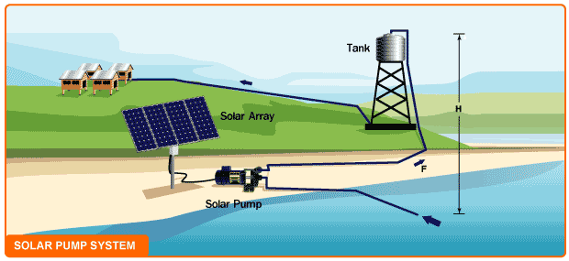

POSSIBLE WATER SOURCES
The SPV based pumpsets are low head high discharge and may be productively used at sites where water is available at relatively shallow level. The possible water sources for the SPV systems are Diggies; pen dug wells, tanks, farm ponds and surface water from canals and rivers.
Submersible Pumps
Submersible pumps are installed completely underwater, including the motor. The pump consists of an electric motor and pump combined in a single unit. Typically the pump will be shaped like a long cylinder so that it can fit down inside of a well casing. Although most submersible pumps are designed to be installed in a well, many can also be laid on their side on the bottom of a lake or stream. Another common installation method for lakes and rivers is to mount the submersible pump underwater to the side of a pier pile (post). Submersible pumps don't need to be primed since they are already under water. They also tend to be more efficient because they only push the water, they don't need to suck water into them. Most submersible pumps must be installed in a special sleeve if they are not installed in a well, and sometimes they need a sleeve even when installed in a well. The sleeve forces water coming into the pump to flow over the surface of the pump motor to keep the motor cool. Without the sleeve the pump will burn up. Because the power cord runs down to the pump through the water it is very important that it be protected from accidental damage. You wouldn't want a boat tangled up in the cord or a snapping turtle or alligator to bite through it

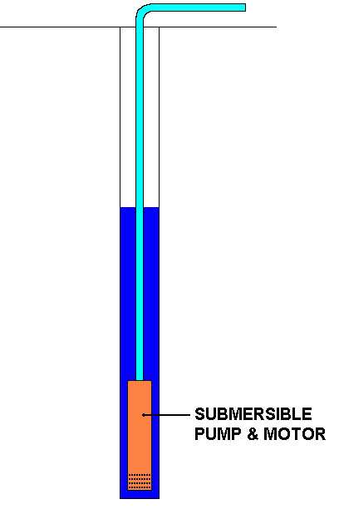
A Submersible Pump
Turbines and Jet Pumps
A turbine pump is basically a centrifugal pump mounted underwater and attached by a shaft to a motor mounted above the water. The shaft usually extends down the center of a large pipe. The water is pumped up this pipe and exits directly under the motor. Turbine pumps are very efficient and are used primarily for larger pump applications. Often they consist of multiple stages, each stage is essentially another pump stacked on top of the one below. It works like a train with multiple engines hitched together pulling it, each stage would be a engine. Turbine pumps are typically the type of pumps you see on farms. When you see a huge motor mounted on its end and a pipe coming out sideways below the motor, that is most likely the motor for a turbine pump down inside the well. I use turbine pumps for large parks and golf courses where we are pumping from lakes. The turbine pump is mounted in a large concrete vault with a pipe connecting it to the lake. The water flows by gravity into the vault where it enters the pump. The pump motors are suspended over the vault on a frame. I usually use two or three different sized pumps side-by-side to handle different flow combinations. A jet pump is similar to a turbine pump but it works by redirecting water back down to the intake to help lift the water.
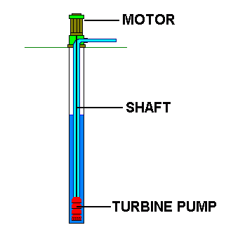
PUMPSETS FOR PHOTO VOLTAIC POWER
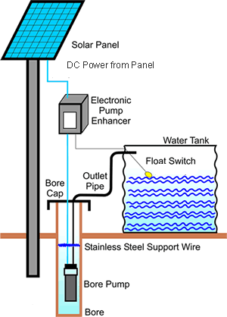
The solar pump unit consists essentially of a solar array, a direct-current electric motor and a pumping unit. The other components are the electrical control and some mechanism for tracking the array against the sun. Many types of pumping sets are used with photovoltaic systems, a vertical centrifugal pump coupled to a submersible DC electric motor or an ordinary volute centrifugal pump close-coupled to a horizontal DC electric motor. However, the submersible pump unit is more suitable for the photovoltaic system. The arrangement eliminates the suction pipe and foot valve and results in a higher efficiency of the pumping unit. The submersible pump is made leak-proof by a silicon carbide mechanical seal. In case of volute pump, care is taken to limit the pump suction within about 5m to maintain a high level of pump efficiency.
The output of the solar array varies with the intensity of the incoming radiation and other factors. Hence, it is necessary to match a variable-speed DC motor with the panel output. At least one make of photovoltaic powered pumping sets utilizes a maximum power-control unit as an integral part of the system, in order to match the load on the pump to the varying power output of the panel.
There is considerable commercial interest in manufacturing photovoltaic powered pumping sets. The power output of the system is directly proportional to the number of solar cells and the surface area of the panel exposed to the sun. The discharge of a solar pump with array area of 2-4m varies from 6-8 lits/s at a head of 5 m. This could irrigate about 1.5 - 2 ha of land with crops having moderate irrigation requirements or may provide protective irrigation to even a larger command.

SYSTEM COMPONENTS
Sr. No. | Description | Qty
1 | Solar Modules 75 wp | 24 nos
2 | Array tracking structure | 1 no.
3 | DC surface centrifugal pump- 2 HP | 1 no.
4 | Array junction box | 1 no.
5 | Installation kit | 1 no.
6 | 2 " HDPE pipe | 10 mts

Solar Photo Voltaic Pumping system for 1800 watts DC surface system

A user manual shall also be provided by the authorized dealer along with the system. MNES/State Renewable Energy Agencies authorize the dealers of SPV.
MAINTENANCE OF SPV SYSTEM
The supplier provides annual maintenance contract to the beneficiary at Rs. 1950/- after initial guarantee period of 1 1/2 years. The solar panel is expected to provide about 20 years of satisfactory service under normal conditions, even though the cell itself may last much longer. The only maintenance requirement is occasional washing of the surface to maintain maximum optical transmission through the glass. The panel has to be protected from breakage by external agencies. Some manufacturers cover the cell/array with unbreakable glass. The motor and the pump require the usual periodic maintenance like cleaning, lubrication and replacement of worn parts.
ADVANTAGES OF SPV PUMPING SYSTEM
Cost effective: The life cycle and the cost to ultimate beneficairy make the SPV systems cost effective as compared to conventional systems. IN addition the farmer is saved from the capital investment he has to make for drawing lines from the grid to his field/farms.The govt. may save huge resources which otherwise may be uneconomical to network every agriculture field under the state electricity grid.
Reliable: The SPV is more reliable, consistent and predictable power option as compared to conventional power system in rural areas.
Free fuel: Sunlight, the fuel source of SPV system is a widely available, inexhaustible, and reliable and free energy source.Hence the SPV system has no monthly fuel bills.
Low maintenance: The system operates on little servicing and no refueling, making them popular for remote rural areas, hence the operation and maintenance is very low. The suppliers provide maintenance at a very low annual maintenance contract rates.
Local generation of power: The SPV system make use of local resource-sunlight. This provides greater energy security and control of access to energy.
Easy transportation: As SPV systems are modular in nature they can easily be transported in pieces/components and are easily expandable to enhance the capacity
Energy Conservation: Solar energy is clearly one of the most effective energy conservation programs and provides a means for decentrailized PV-generated power in rural areas. Solar pump is energy efficient and a decentralized system avoids any unnecessary expenditure on T & D networks
Water conservation: The SPV sets are highly economical when combined with water conservation techniques such as drip irrigation & night time distribution of (day time pumped & stored) water. The SPV system leads to optimum exploitation of scarce ground water.
Environmental friendly : The use of sunlight as a source of fuel leads to clean, eco-friendly and decentralized generation of energy which saves the fossil fuel, controls deforestation and prevents environmental pollution.
BENEFITS TO FARMERS
Farmer gets a high value, high discharge pumping system for a one time amount that is less than a third of the actual price and may be maintained at nominal cost annually.
- No fuel costs & minimal maintenance costs.
- More economical than diesel pump sets in the long run.
- Where no pumping system exists at present SPV based pumping system,
- Enables cultivation of an extra crop
- Helps in providing the critical protective irrigation in water scarce areas.
- Saves time and labour
- Improves agriculture productivity
- Improves general quality of life with higher levels of income
- Incremental income enables easy repayment loan taken for installing system.

EXTENSION SERVICES
Adequate extension services are made available by agencies/suppliers in the scheme area. The beneficiaries may adopt modern cultivation practices and adopt crop diversification with an emphasis on cash crop/high remuneration crops. The guidance may be availed from local agriculture extension departments of the state government.
CONCLUSION:-
- Potentially high initial system costBut it gives more benefit in long time.
- Low labor and maintenance costs.
- No fuel costs.
- Easy to remove, transport, and store.
- Produces water during sunny weather when it’s needed most.
- Reliable and long life.
- Non-polluting.
REFERENCES:-
- www.solarwater.com
- www.pvsolarpump.com
- www.tradeindia.com/solar-water-pumping-system
- www.builditsolar.com/WaterPumping/waterpumping
- www.leonics.com/Solar Photovoltaic Systems
- www.solardyne.com/solwatpum
- www.geda.org.in/solar
- www.indiawaterportal.org

